GPS accuracy

Our dear friends from Australia (Ozzmaker company to be accurate) send us wonderful BerryGPS-IMU V3. This module is so cool that when we first saw it, we knew that it must be one of the components of our can. And here it is! We’re using it as our GPS. We decided to check its accuracy compared with phone that has really precise GPS.
Let’s start with some photos:

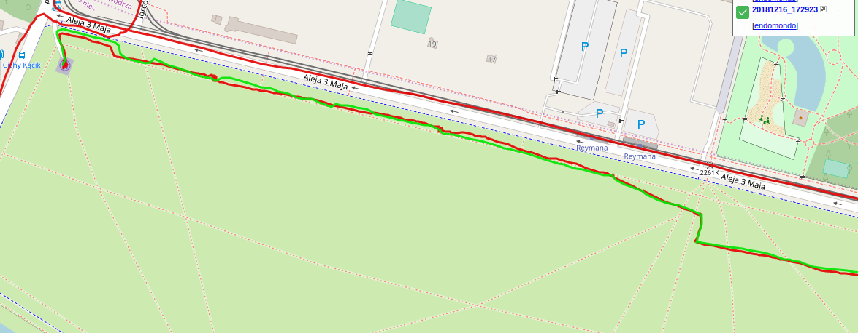
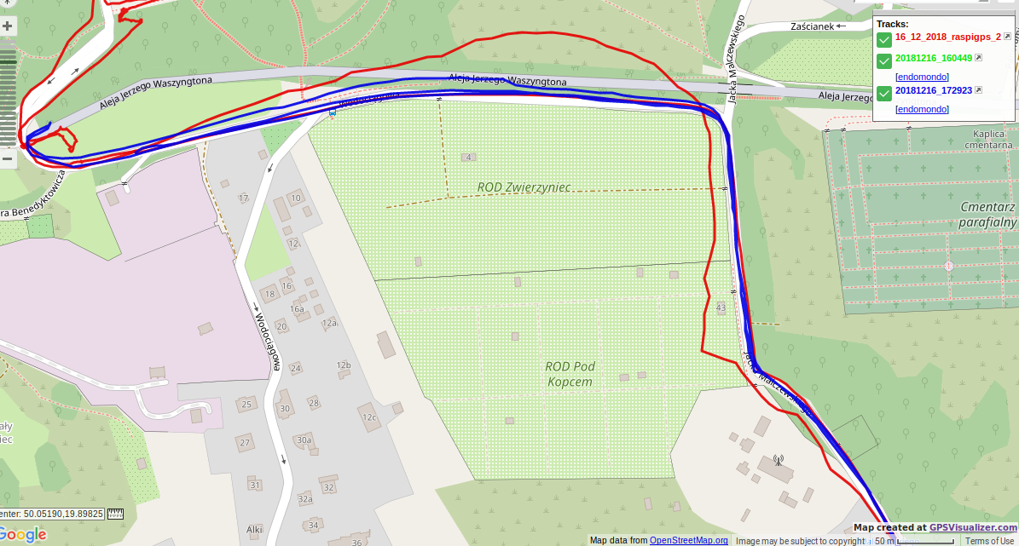
red line – BerryGPS-IMU, green line – phone
// the red line that is above is from another track, don’t care about it
red line – BerryGPS-IMU, blue line - phone
After having found GPS fix, the track designated by Berry IMU is almost the same as the track appointed by phone which has really precise GPS. But when Berry loses contact with some satellites, its readings start to differ from reality. During our test, the biggest measurement error was equal to around 50 m and it was noted when our module was inside a car and its velocity started to grow. After a while the number of available satellites increased so consequently the measurements became more precise again.
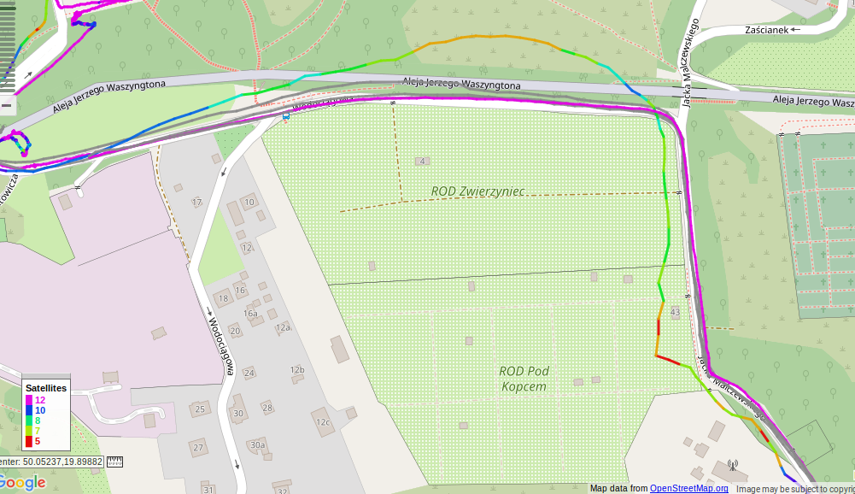
The higher the number of satellites, the more accurate the results.
see legend – the bottom left corner

Although sometimes BerryGPS IMU has some problems with indicating the proper route, we assume that those differences aren’t really significant . Taking into account all situations when we used this module and compared its readings to another source, we were always satisfied. We are thus ready to confide in BerryGPS’s measurements.

We have also tested how does BerryGPS perform without external antenna. Being in a car, there were a lot of problems with obtaining a fix – measurements were really deformed. But getting out of the car didn’t help much. There is only one conclusion: without external antenna the measurements are not accurate.
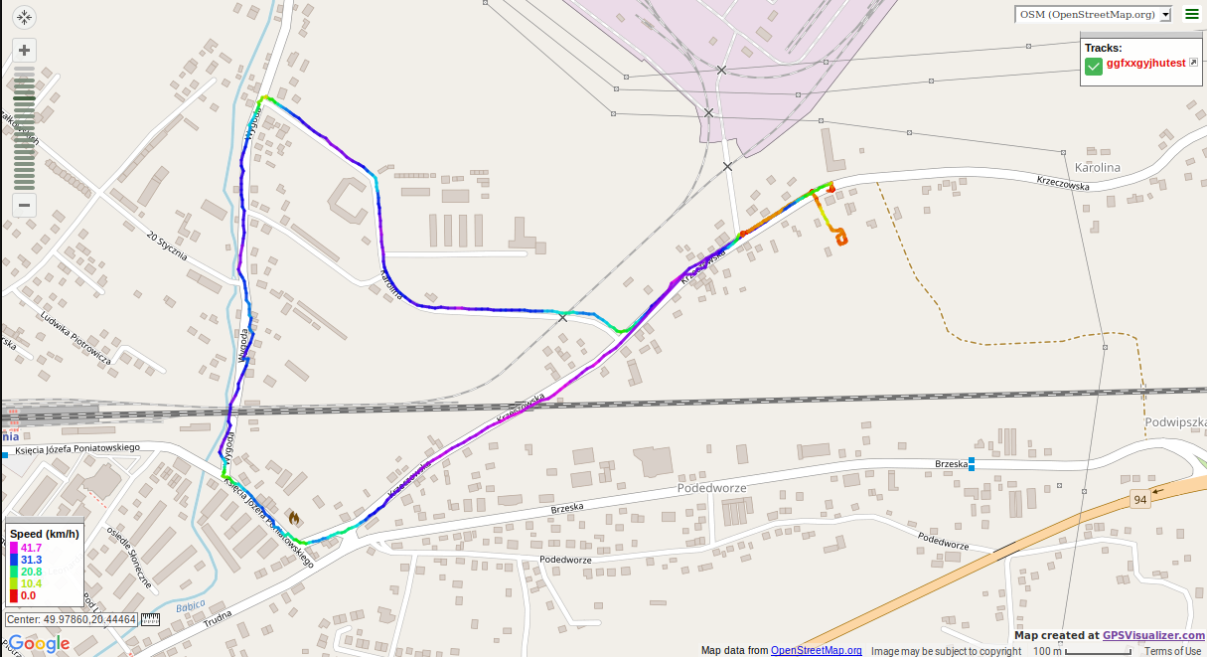
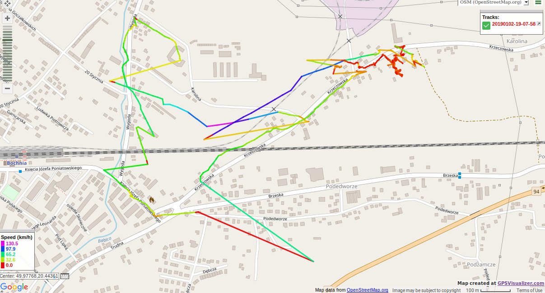
with external antenna
without external antenna

